BOOK STORE PROJECT

--Question 1 Retrieve all books in the "Fiction" genre
SELECT*FROM books;
SELECT COUNT(*) AS fiction_book
FROM BOOKS
WHERE GENRE = 'Fiction'
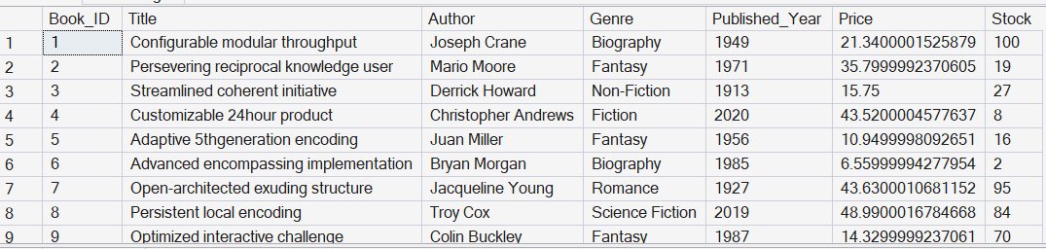
--Question 2 Find books published after the year 1950
SELECT*FROM books
WHERE Published_year >1950;
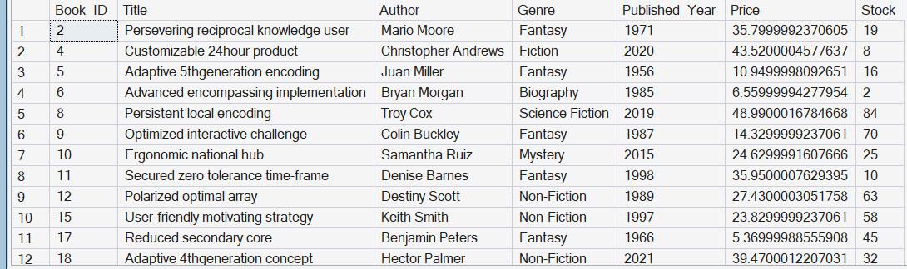
--Question 3 List all customers from the Canada
SELECT*FROM Customers
WHERE COUNTRY = 'Canada';
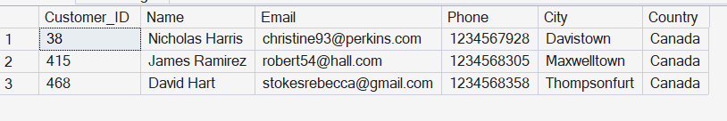
-- Question 4 Show orders placed in November 2023
SELECT *FROM Orders
WHERE Order_Date BETWEEN '2023-11-01' AND '2023-11-30';
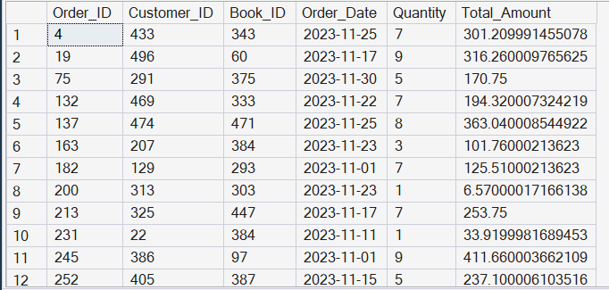
-- Qestion 5 Retrieve the total stock of books available
SELECT SUM(Stock) AS Total_Stock
FROM Books;
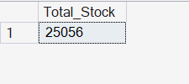
-- Question 6 Find the details of the most expensive book
SELECT *FROM Books
WHERE Price = (SELECT MAX(Price) FROM Books);
-- Question 7 Show all customers who ordered more than 1 quantity of a book
SELECT *FROM orders
WHERE Quantity > 1;
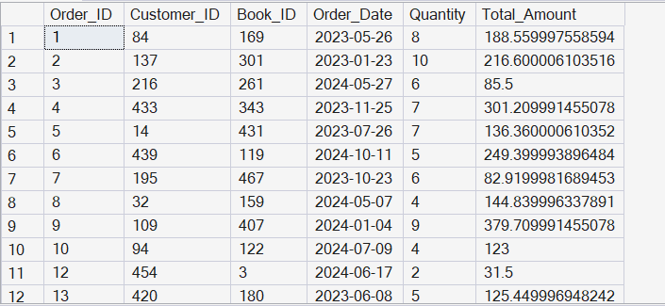
-- Question 8 Retrieve all orders where the total amount exceeds $20
SELECT *FROM Orders
WHERE Total_Amount > $20;
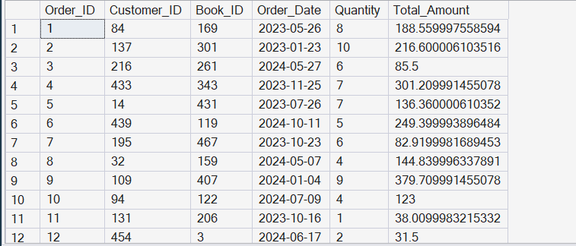
-- Question 9 List all genres available in the Books table
SELECT DISTINCT Genre
FROM Books;
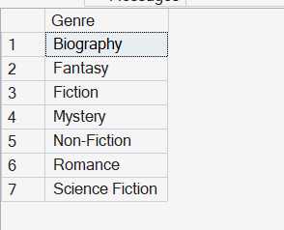
-- Question 10 Find the book with the lowest stock

SELECT TOP 1 *
FROM Books
ORDER BY Stock ASC;
-- Question 11 Calculate the total revenue generated from all orders Advance Queries
SELECT SUM(Total_Amount) AS Total_Revenue
FROM Orders;
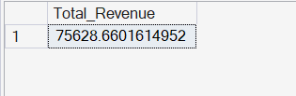
-- Question 12 Retrieve the total number of books sold for each genre
SELECT B.Genre, SUM(O.Quantity) AS Total_Books_Sold
FROM Books B
JOIN Orders O ON B.Book_ID = O.Book_ID
GROUP BY B.Genre;
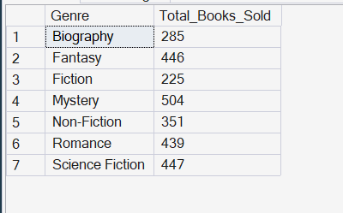
-- Question 13 Find the average price of books in the "Fantasy" genre
SELECT AVG(Price) AS Average_Price
FROM Books
WHERE Genre = 'Fantasy';
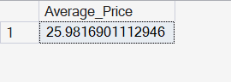

-- Question 14 List customers who have placed at least 2 orders
SELECT C.Customer_ID, C.Name, COUNT(O.Order_ID) AS Total_Orders
FROM Customers C
JOIN Orders O ON C.Customer_ID = O.Customer_ID
GROUP BY C.Customer_ID, C.Name
HAVING COUNT(O.Order_ID) >= 2;
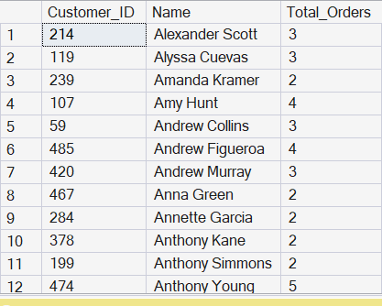

-- Question 15 Find the most frequently ordered book
SELECT TOP 1 B.Title, SUM(O.Quantity) AS Total_Quantity
FROM Books B
JOIN Orders O ON B.Book_ID = O.Book_ID
GROUP BY B.Book_ID, B.Title
ORDER BY SUM(O.Quantity) DESC;

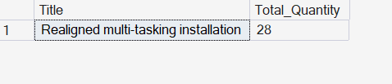

-- Question 16 Show the top 3 most expensive books of 'Fantasy' Genre
SELECT TOP 3
Book_ID,Title,Author,Genre,Published_Year,
ROUND(Price, 2)AS Price,Stock
FROM Books
WHERE Genre = 'Fantasy'
ORDER BY Price DESC;
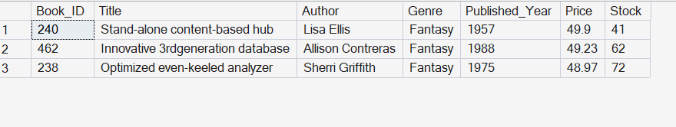

-- Question 17 Retrieve the total quantity of books sold by each author
SELECT B.Author, SUM(O.Quantity) AS Total_Sold
FROM Books B
JOIN Orders O ON B.Book_ID = O.Book_ID
GROUP BY B.Author;
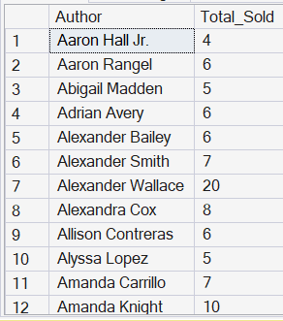

-- Question 18 List the cities where customers who spent over $30 are located
SELECT C.City
FROM Customers C
JOIN Orders O ON C.Customer_ID = O.Customer_ID
GROUP BY C.Customer_ID, C.City
HAVING SUM(O.Total_Amount) > 30;
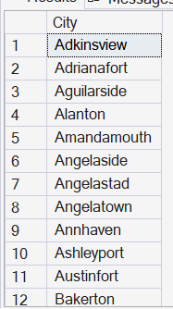

-- Question 19 Find the customer who spent the most on orders
SELECT TOP 1 C.Name, SUM(O.Total_Amount) AS Total_Spent
FROM Customers C
JOIN Orders O ON C.Customer_ID = O.Customer_ID
GROUP BY C.Customer_ID, C.Name
ORDER BY SUM(O.Total_Amount) DESC;
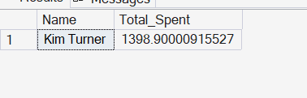

-- Question 20 Calculate the stock remaining after fulfilling all order
SELECT B.Book_ID, B.Title,
B.Stock, COALESCE(SUM(O.Quantity), 0) AS Remaining_Stock
FROM Books B
LEFT JOIN Orders O ON B.Book_ID = O.Book_ID
GROUP BY B.Book_ID, B.Titl
